Round the World Cruise Presentation
By
Laurie Moeller Owen
Saginaw Bay YC
Sept. 24, 2015
8 PM

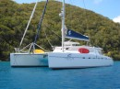
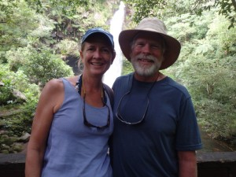

Laurie Moeller Owen, who just finished an around the world cruise with her husband, Russ on a Nexus/Balance 600 catamaran will be giving a free a presentation on her adventure Thursday the 24th., 8 PM at the Saginaw Bay YC, Essexville. Lifelong sailors, Russ and Laurie decided to fulfil a lifelong dream and take this voyage after Russ retired as an Aerospace Engineer and former senior executive for CSC. Laurie was speech pathologist but more recently volunteers for several charitable organizations. Laurie's boating started on the Saginaw Bay a number of years ago. Her father, Dr. Arlen Moeller, was an active member at SBYC for many years.
. The link to her blog while at sea is:
http://www.sailblogs.com/member/nexuscruising/?xjMsgID=359692

GLCC members and their guests are welcome to have dinner at the Club prior to the talk.
Please contact Craig Murchison, Deputy Port Captain of Bay City if you are interested.
Cbmurch2@gmail.com
989-295-0810

